PERSONAL INVESTMENT INCOME/PROFIT SHARE  PROMISE NOTE  % 30  EARNING  12/30/2022  06/30/2023  BUSINESS PROGRAM |  |  |  |  |  |  | ……………….  RESTAURANT  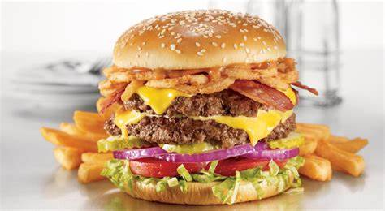  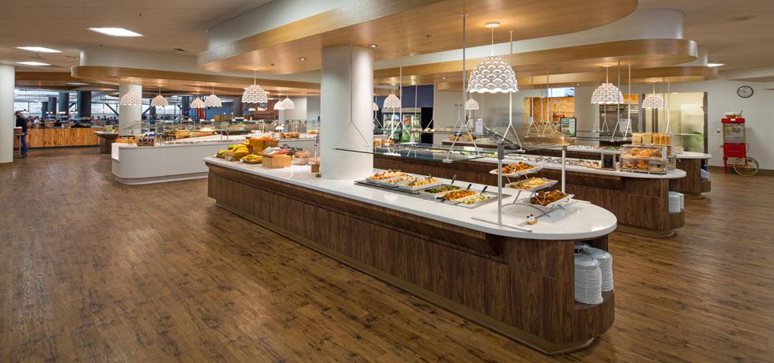  WWW.ABCDE@GMAIL.COM
Sample PROMISE NOTE  The amount of ....................., which covers 50% of the money paid for investment purposes, will be used for the purchase of discounted services to the investor/customer or for discounted shopping. The amount of ............... covering the other 50% will be used to generate income/profit share for the investor/customer.  The full balance of the $_______________ amount of money paid for investment and, INCOME/PROFIT SHARE will be paid back in this way; Invested Company shall pay principal and INCOME/PROFIT SHARE installment amounts equal to $_______________ with the first (1st) 6 MONTHLY payment due on 12/01, 2022 and the remaining payments to be paid: 12 MONTHLY with any remaining balance payable on 06/30,2023.  With notarized legal contract this note shall be governed under the laws in the State of New Jersey.  Invested Company and Investor/Customer agree to the terms and The invested company undertakes to repay the investment amount with income/profit share.  Investor/Customer Signature: ______________  Date: ____________  Print Name: ____________________________  Behalf of invested company legal signatory  Signature: ____________________________  Date: ____________  Print Name: ________________________Title ____________ |  | Company Name  Street Address  City, ST ZIP Code |  |  | INVESTED COMPANY  Company Name  Company Industry  Business-Brand Name  Web Site  Address  Branches Address  Founding Year  ITIN Tax Number  Authorized Name/Title  Mobile Phone  E-Mail Address  PRE-FINANCE AMOUNT$  DEPOZIT DATE  DEPOZIT BANK NAME  SHARE RATE %( DISC/INV)  DISCOUNT AMOUNT -$  INVEST AMOUNT -$  DISCOUNT RATE %  INVEST RATE %  PLAN DURATION/Monthly  COUPON USED DATE AMOUNT INVESTED COMPANY SIGN  1st share date  2st share date  3st share date  4st share date  ……………….  RESTAURANT

